2026 Finance API Suite — Developer Guide

Overview
The 2026 Finance API suite provides programmatic access to seller financial data, enabling integrators to build automated workflows for balance monitoring, payout tracking, and financial reconciliation. The suite consists of three APIs:
- Balances API — Retrieves point-in-time balance snapshots including available, account level reserves, and deferred balances. (Balance Summary Widget)
- Financial Summary API — Returns aggregated financial summaries with standardized category-level breakdowns (sales, fees, refunds, taxes) for a specified time period or Settlement ID. List of settlement ids can be obtained using Payouts API. (Financial Overview Widget)
- Payouts API — Provides payout lifecycle tracking from initiation through bank deposit, including status transitions, bank details, and settlement references. (Payouts Summary Widget)
Together, these APIs give selling partners and their authorized integrators a complete view of financial activity across the seller lifecycle — from daily balance monitoring to monthly reconciliation.

Next Gen Selling
Each API powers a widget in Finance Workspace in Next Gen Selling, the new version of Seller Central.

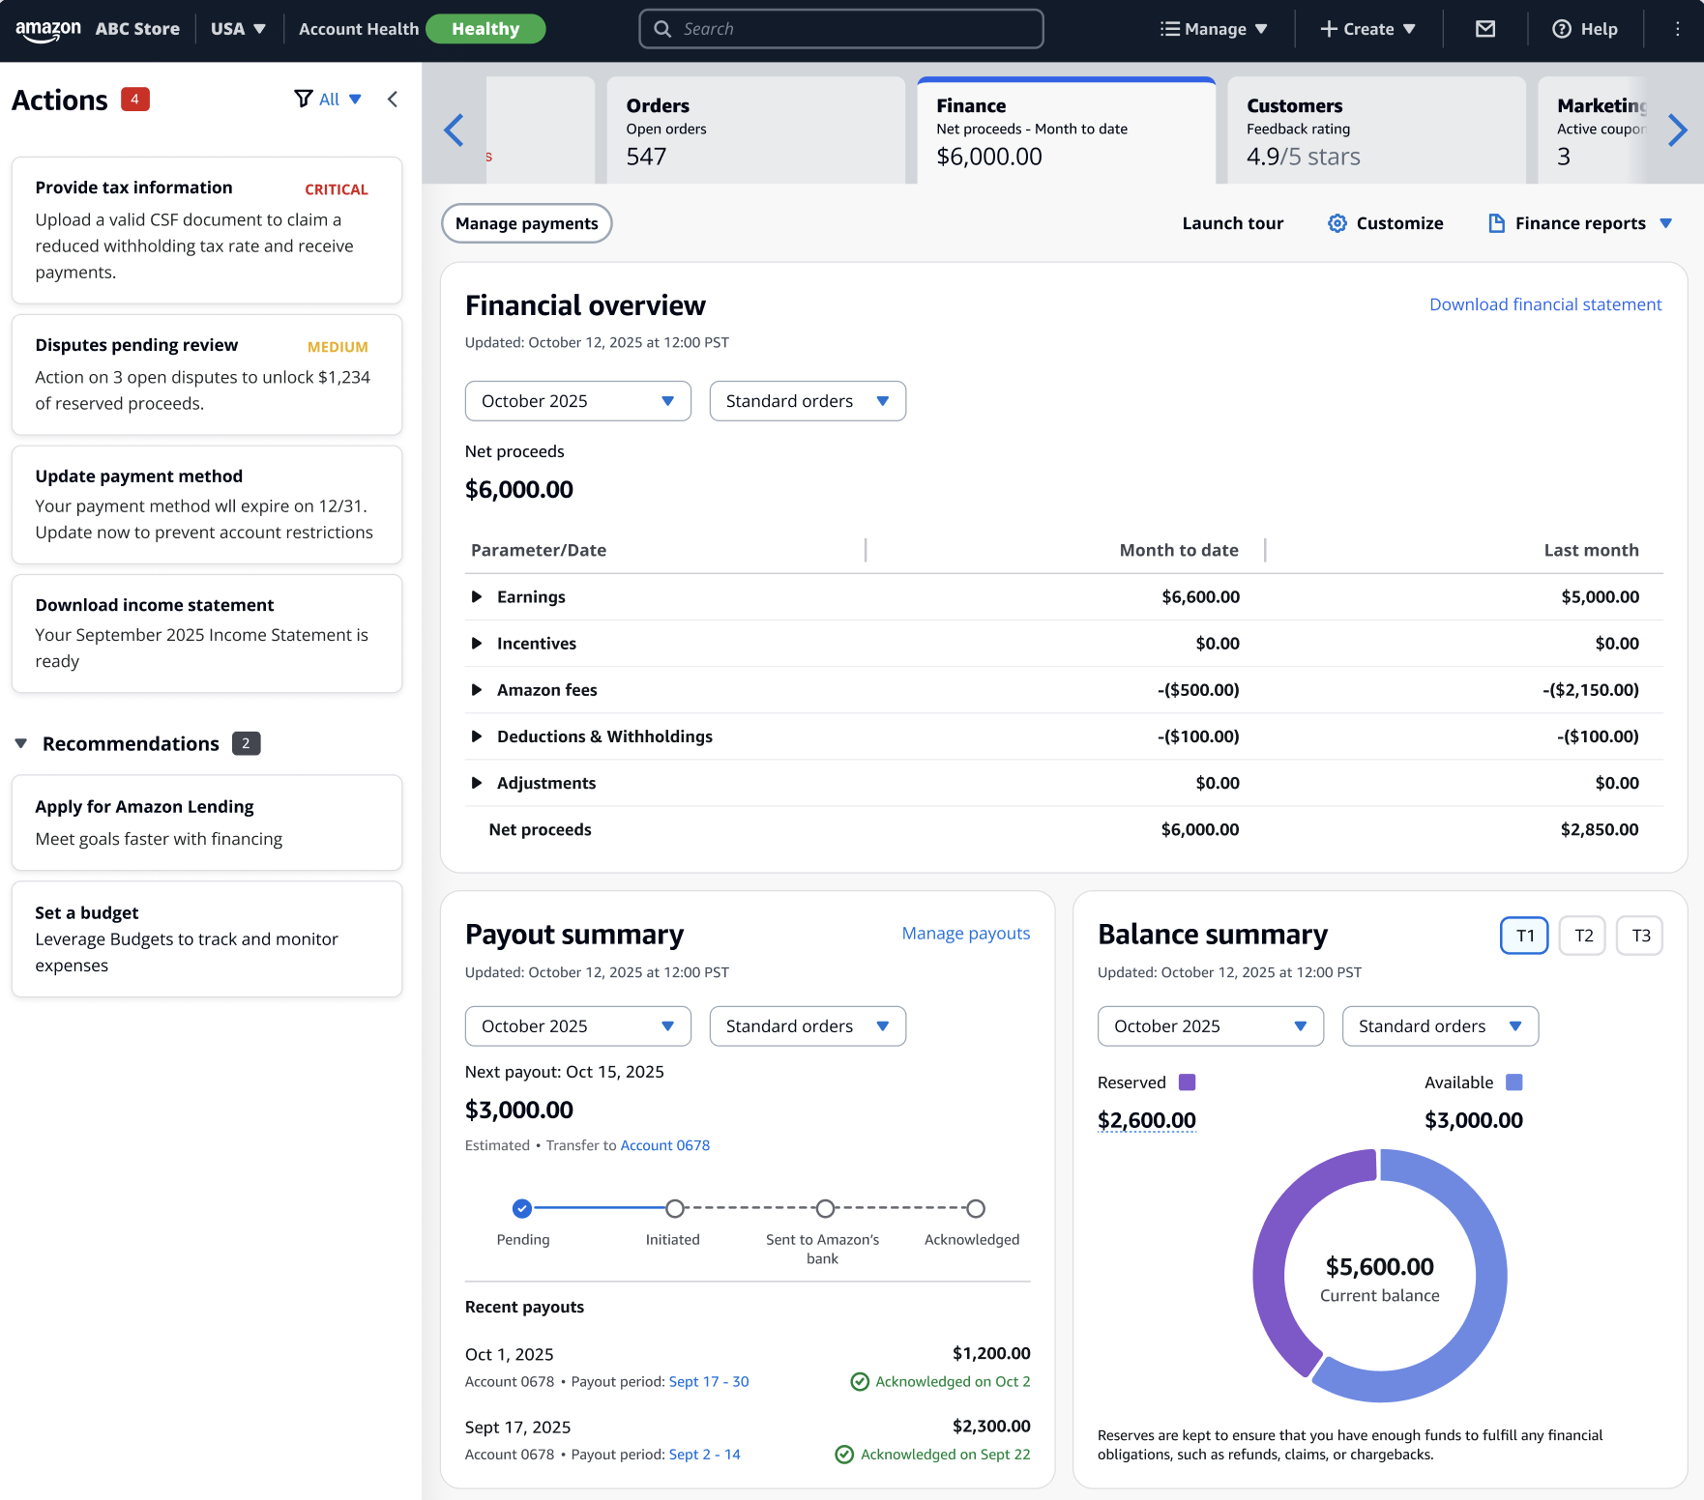

How These APIs Map to the Seller Lifecycle
The three APIs in the 2026 Finance API suite are designed to address distinct stages of a seller's financial workflow. The sections below describe each stage, the APIs involved, and how integrators can use them.

1. Daily Monitoring and Analytics
APIs Used: Balances API, Financial Summary API

Sellers and integrators need to monitor financial health on a daily basis. The Balances API provides point-in-time balance snapshots with a split by balance types (Available and Reserved Balance). In the Private Beta release, the Balances API returns the current balance. A future release will introduce date parameters (asOfDate) to retrieve historical balances, enabling sellers to track how their balance changes day over day.

The Financial Summary API complements this by providing aggregated financial summaries using a standardized taxonomy. The Financial Summary API is available starting March 2026 in Private Beta. Integrators receive pre-computed category-level views organized into four L1 categories — EARNINGS, AMAZON_SERVICE_CHARGES_AND_FEES, DEDUCTIONS_AND_WITHHOLDINGS, and OTHERS — each with L2 sub-category breakdowns, without requiring client-side computation or aggregation logic. For the full L1/L2 taxonomy with classification criteria and all sub-categories, refer to the Standardized Financial Summary Taxonomy section in the Balances and Financial Summary API Reference.

Integration Pattern:
- Call the Balances API to retrieve the current balance. In a future release, the periodEnd parameter will enable retrieval of historical daily balances.
- Call the Financial Summary API with periodStart and periodEnd to retrieve financial activity for a given day or date range. These dates are inclusive, meaning to get financial activity for 3/1/26, use 3/1/26 as createdAfter and createdBefore. These summaries are calculated based on the marketplace timezone of the seller and not UTC.
- Combine both responses to give sellers a dashboard view of their financial position and activity.

2. Weekly Payout Tracking
APIs Used: Payouts API
Sellers typically receive payouts on a biweekly cadence. The Payouts API provides payout tracking across three stages:
- STARTED — Processing has been initiated for the settlement.
- IN_TRANSIT — The payout has been sent to the bank provider.
- PAID — The payout has been received by the bank provider.
- FAILED — The payout failed due to bank failure or a technical failure. Exact failure reason code to follow in P1.
Integration Pattern:
- Call the Payouts API with createdAfter and createdBefore to retrieve all payouts within a date range. Here the createdAfter and createdBefore timestamps are in UTC.
- Call the Payouts API with a specific payoutId to retrieve detailed status and state transitions for a single payout.
- Use the accountTail and paymentRail fields for compliance monitoring and bank account change detection.

3. Monthly Reconciliation (Month-End Close)
APIs Used: Financial Summary API, Payouts API, Balances API

For month-end close (MEC) reconciliation, sellers align their cash position with their financial position (monthly earnings). The reconciliation follows this equation: (LHS) Sales − Taxes − Fees − Refunds = (RHS) Cash Received + Remaining Balance.
- Left-Hand Side (LHS): Net financial activity for the month, representing what the seller earned after all deductions. Use the Financial Summary API to retrieve aggregated totals for the month.
- Right-Hand Side (RHS): Actual cash position, combining what was paid out plus what remains in the seller's Amazon account. Use the Payouts API to identify payouts received during the month and the Balances API to obtain outstanding balances.
When LHS equals RHS, the seller's books are reconciled and accurate.
Note: This feature will come as part of the GA launch and would not be available in Beta. The numbers will not match a 100% and there maybe data discrepancies. Please feel free to share the discrepancies as we would like to find out about any major data issues through this Beta launch.

Integration Pattern:
- Call the Financial Summary API for the full month to calculate LHS (net financial activity).
- Call the Payouts API for the same month to sum all payout amounts.
- Call the Balances API to obtain current outstanding balances. In a future release, the periodEnd parameter will enable retrieval of historical closing balances for opening and closing balance calculations.
- Verify that LHS equals RHS.

Authentication and Authorization
All Finances APIs require standard SP-API authentication. Integrators must obtain authorization from selling partners through the SP-API authorization workflow. Refer to the SP-API Authorization Guide for details on obtaining and refreshing access tokens.

Rate Limiting
All endpoints are subject to SP-API rate limits. Supported TPS for Beta launch is 1 TPS. Rate limit information is returned in the x-amzn-RateLimit-Limit response header. If you exceed the rate limit, the API returns HTTP 429 (Too Many Requests). Implement exponential backoff and retry logic in your integration.

What's Next
- API Reference — Balances and Financial Summary: Detailed request parameters, response schemas, enums, and error codes.
- API Reference — Payouts: Detailed request parameters, response schemas, enums, and error codes.
- Appendices: Sample request/response pairs, the Financial Summary taxonomy, and the Month-End Close reconciliation guide.

